BLADED LEVEL GAUGE
Sleeve version
PFG 86 – M
Technical Data

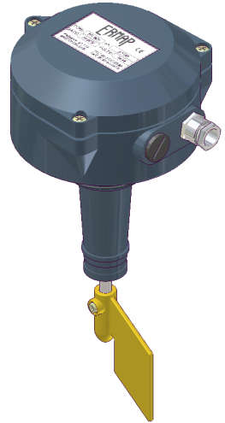

Ambient temperature range: -10°C to +80°C
Maximum operational pressure: 3 bars
Protection: IP65
Weight: 2,4 kg
Power supply available:
24 – 48 Volts AC / 110 – 220 Volts AC / 24 Volts CC
Electric motor absorption: 4 Watts

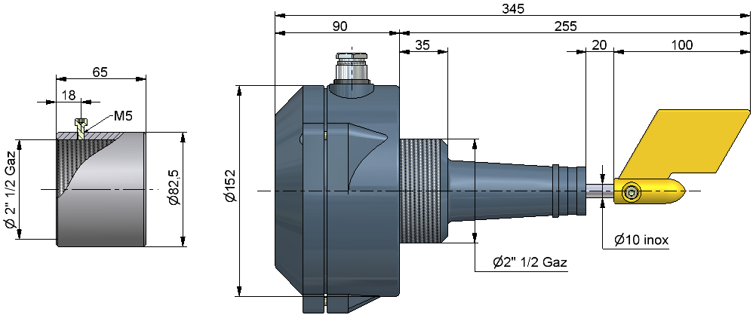
Electric connection:
Pin 1: Common power supply
Pin 2: Power supply 24VAC or DC or 110VAC (according to the model)
Pin 3: Power supply 48VAC or 220VAC (according to the model)
Pin 4: Not used
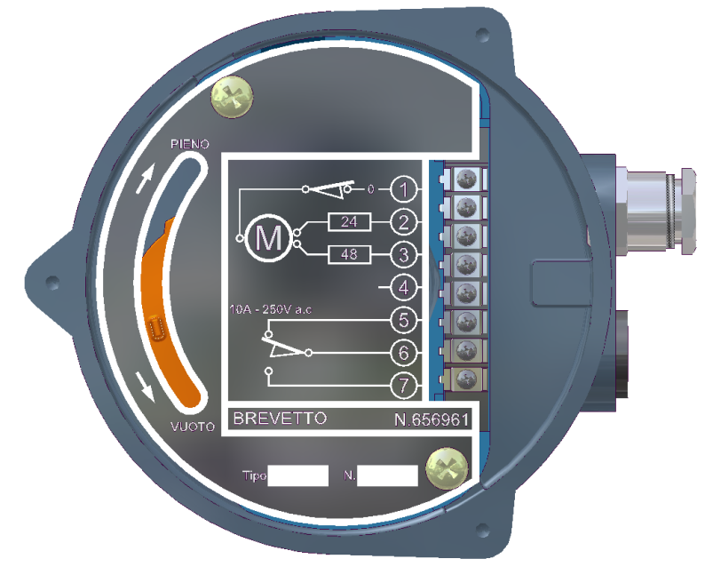
Pin 5: NC Contact (10A-250V)
Pin 6: Common contacts
Pin 7: NO Contact (10A-250V)

Motor connection:

24/48 V AC | Motor cover yellow | Motor cover Orange
Pin 1 switch PIENO | BROWN | BLUE
Pin 2 of wiring plate | BLUE | GREEN
Pin 3 of wiring plate | RED | WHITE

110/220 V AC | Motor cover yellow | Motor cover Orange
Pin 1 switch PIENO | YELLOW | BLUE
Pin 2 of wiring plate | RED | RED
Pin of wiring plate | BLACK | WHITE

24 V CC | Motor cover yellow | Motor cover Orange
Pin 1 switch PIENO | BROWN | BLUE
Pin 4 of wiring plate | BLEU | GREEN
No Connect | RED | WHITE

BLADED LEVEL GAUGE
Sleeve version
PFG 86 – M
Parts list - Assembly

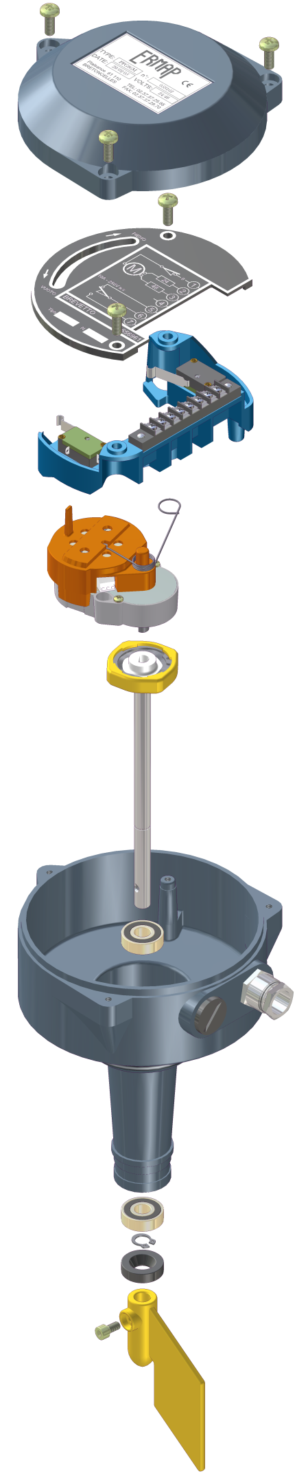

Cover

Identificaton plate ref : PS PFG86

Switch ref : FIN PFG86

Wiring plate (contacts + 2 switchs) ref : STAF PFG86

Motor-réducer (24/48V ou 110/220V) ref : MOT PFG86

Spring ref : MOLLE PFG86

Complet main transmission

Main bearing proof ref : CUSC PFG86

Cable gland ½ gas thread ref : PE PFG86

Body

Main bearing proof ref : CUSC PFG86

Circlips ref : CIR PFG86

Ring proof ref : CORT PFG86

Blade PVC ref : AC4 PVC1

